# Train / Dev / Test sets

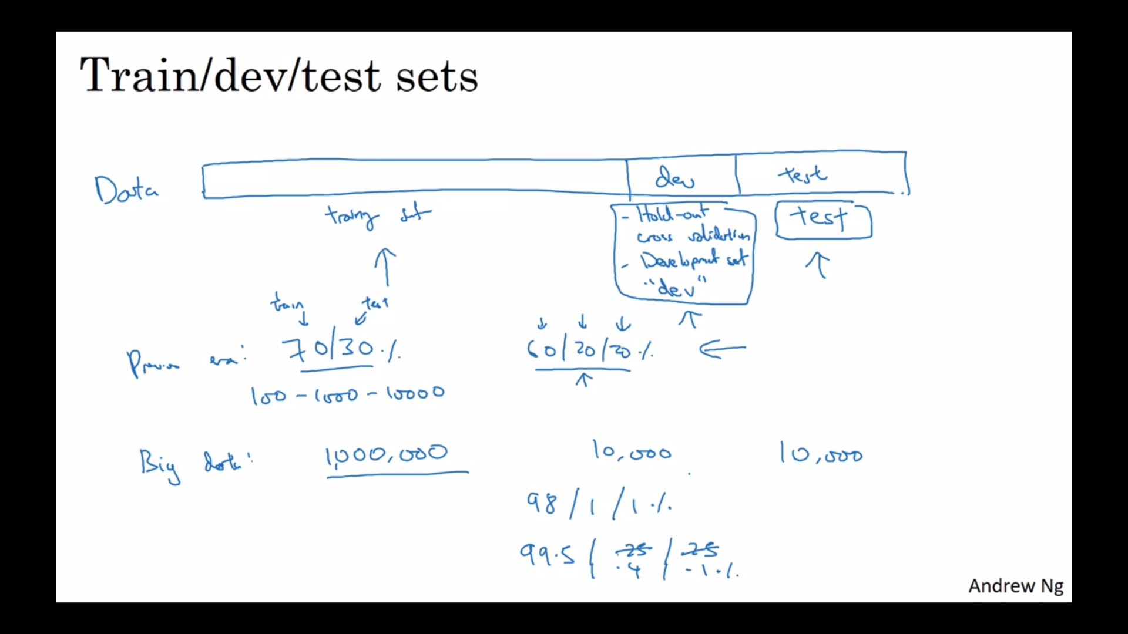

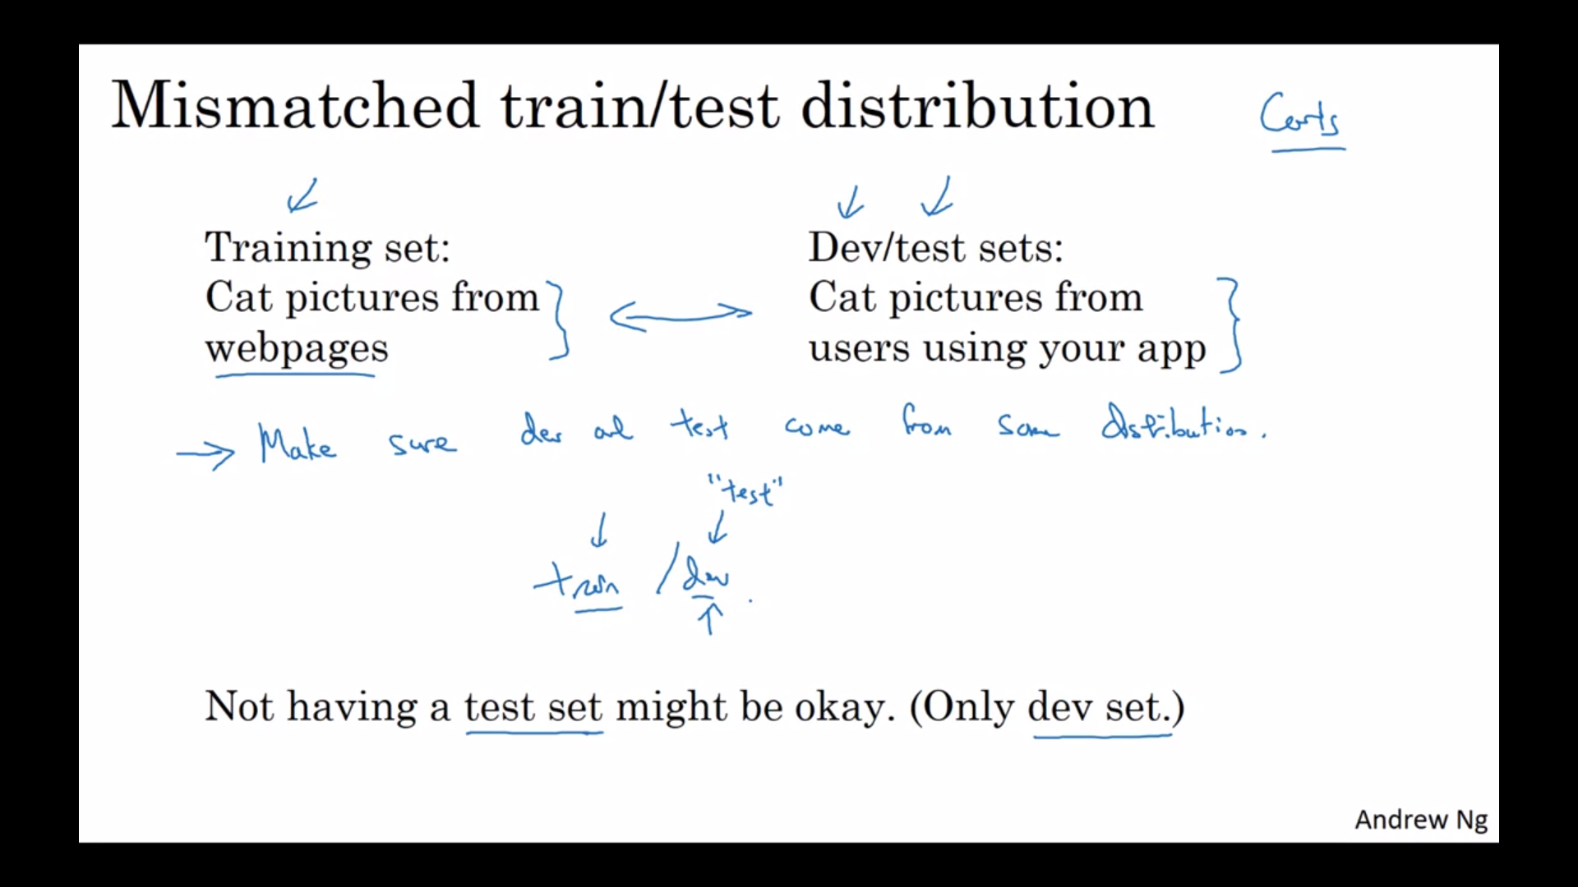

# Bias / Variance

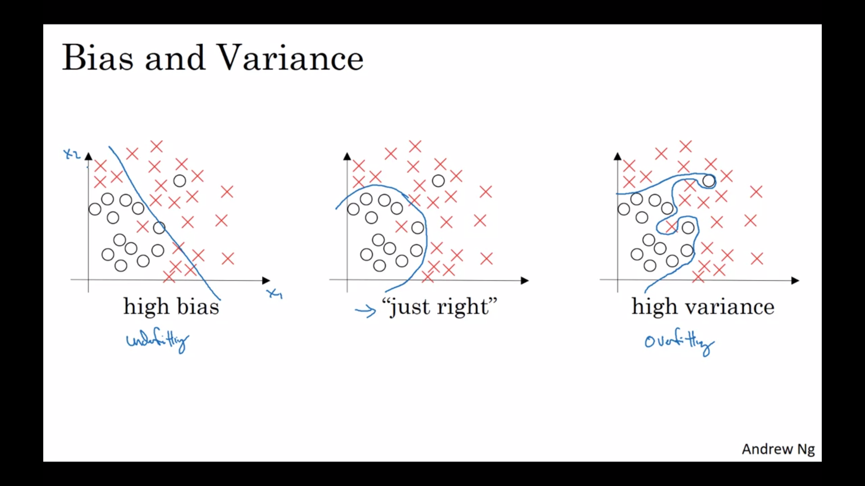

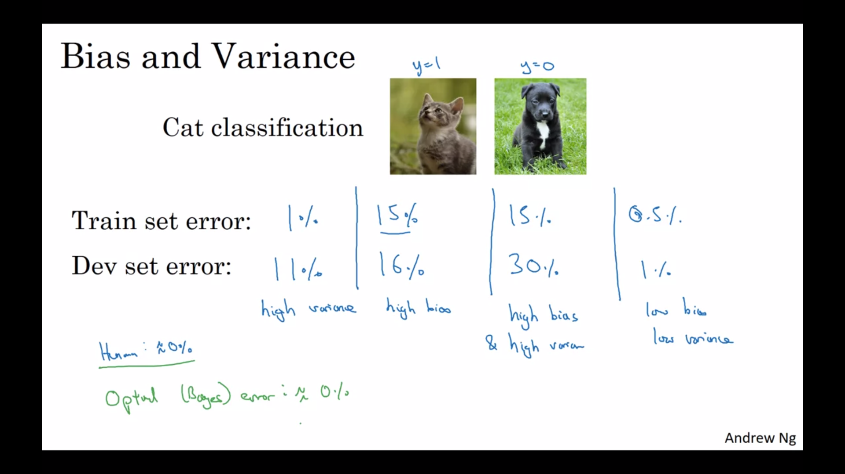

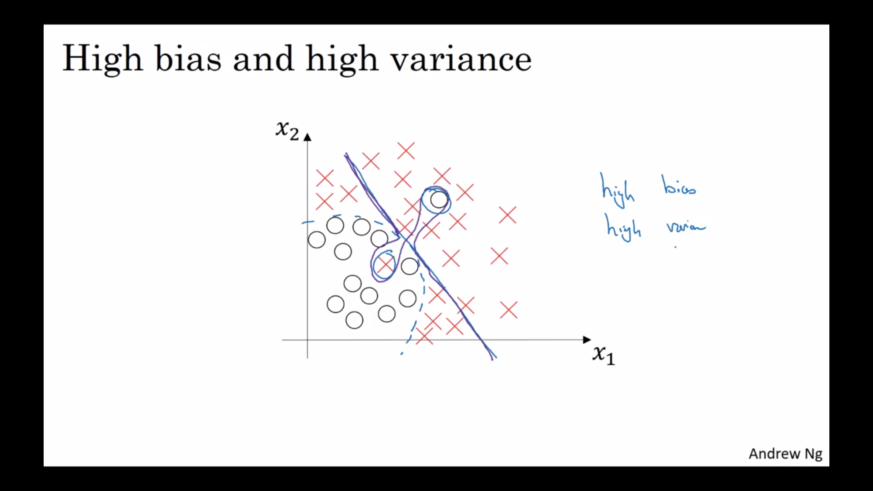Decision boundary in purple shows high bias and high variance.

# Basic Recipe for Machine Learning

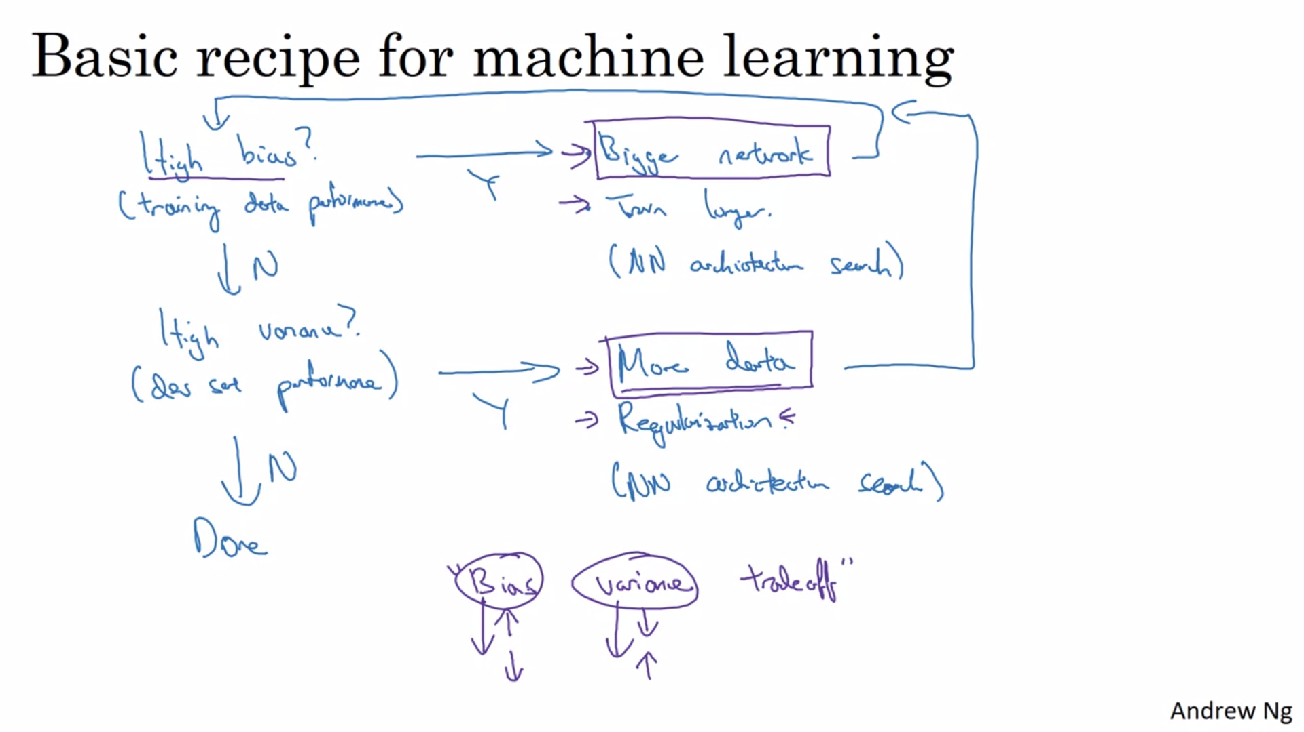

Training a bigger network almost never hurts.

And the main cost of training a neural network that's too big is just computational time,

so long as you're regularizing.

# Regularization

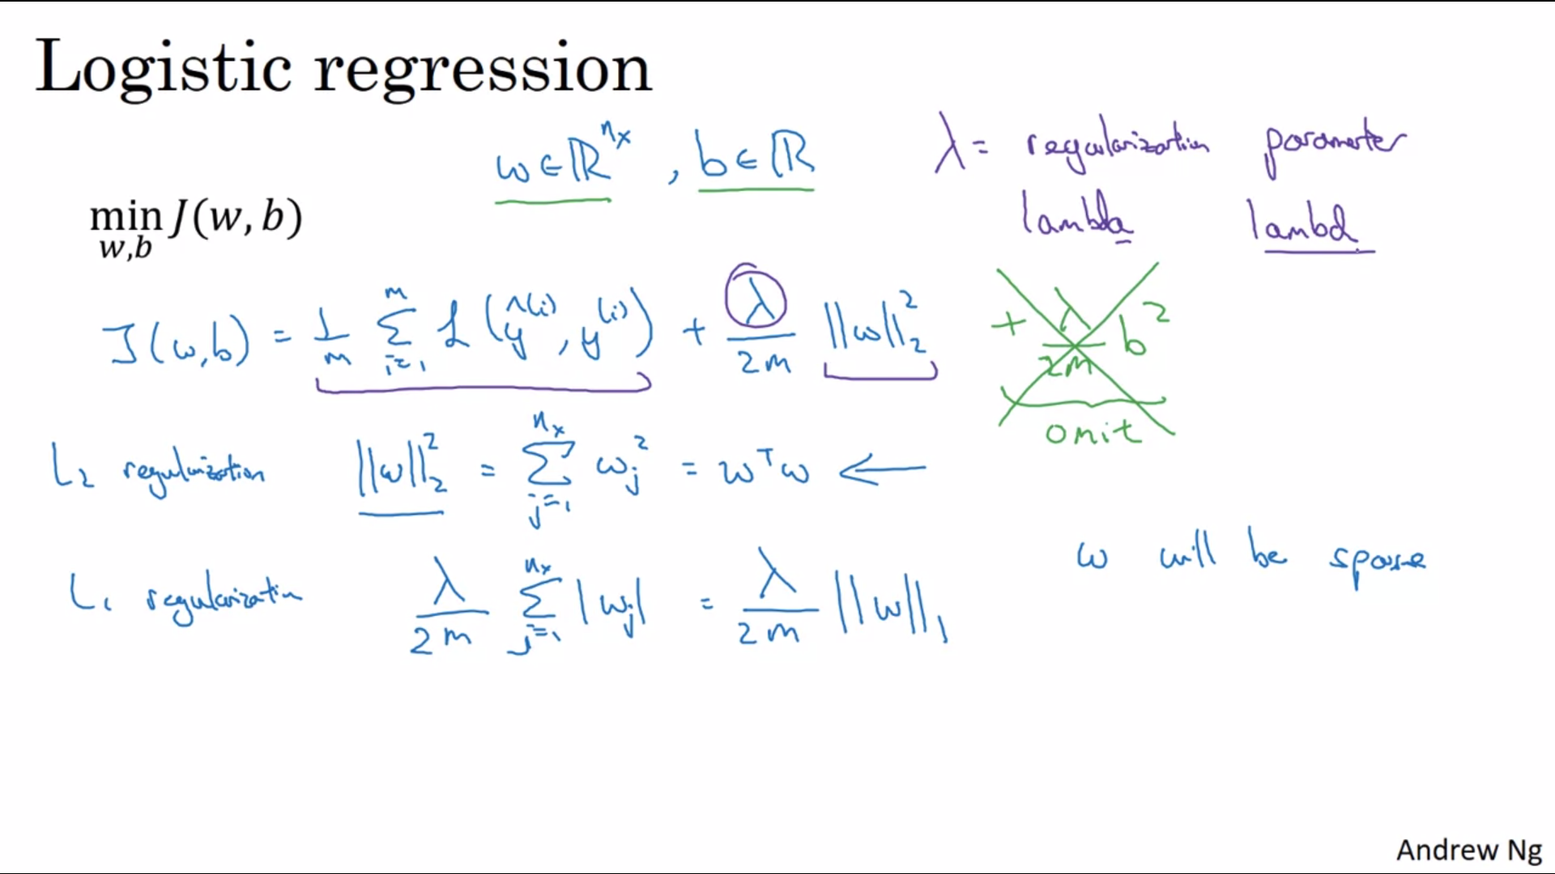

We will use lambd variable name in python since lambda is reserved keyword in python.

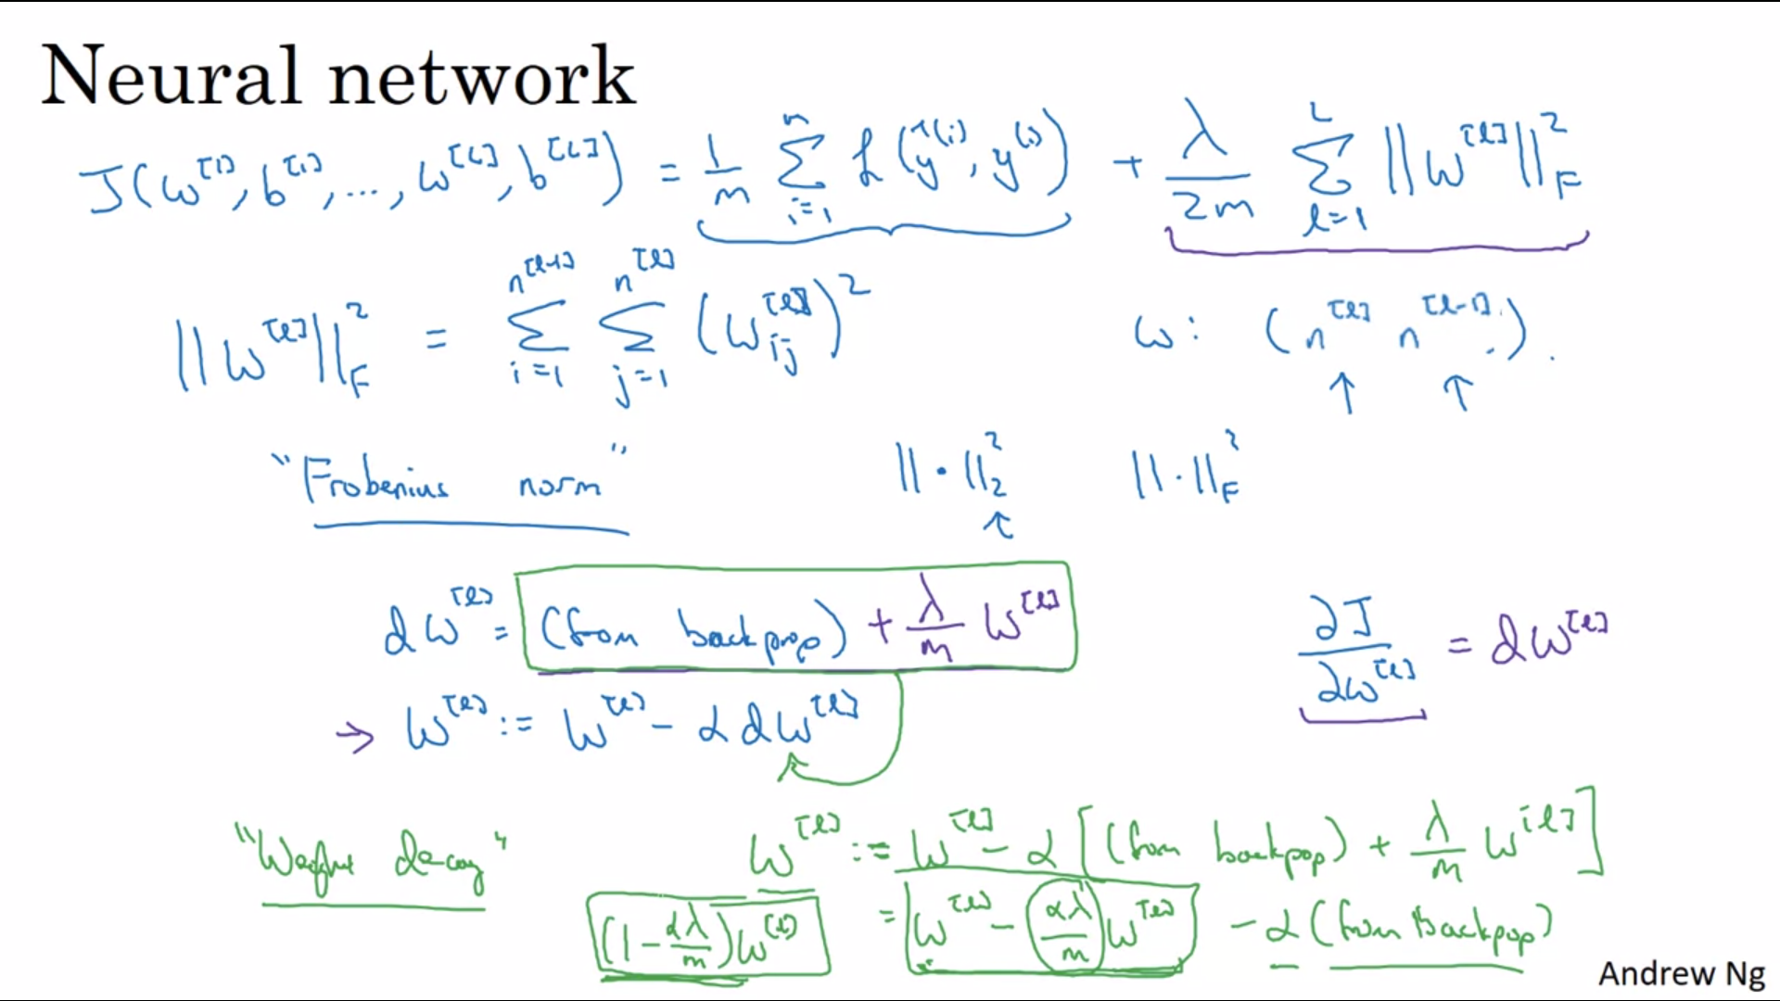

The formula for frobenius norm is incorrect in above image, the correct formula is

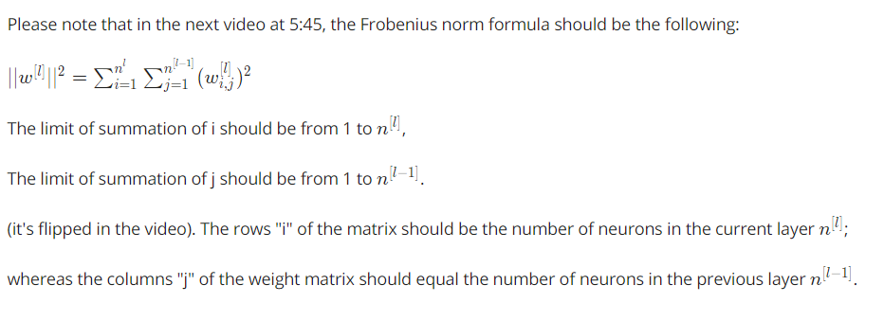

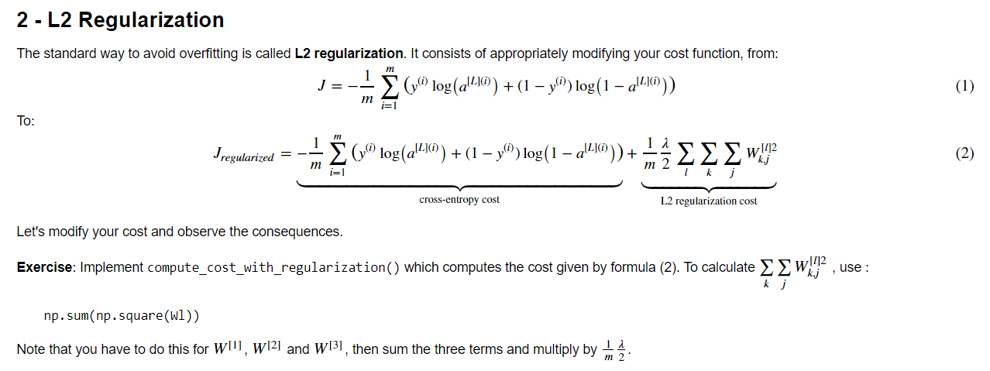

-----

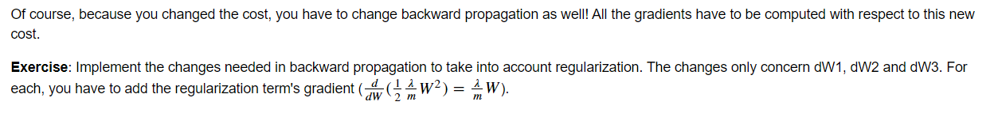

# Why regularization reduces overfitting?

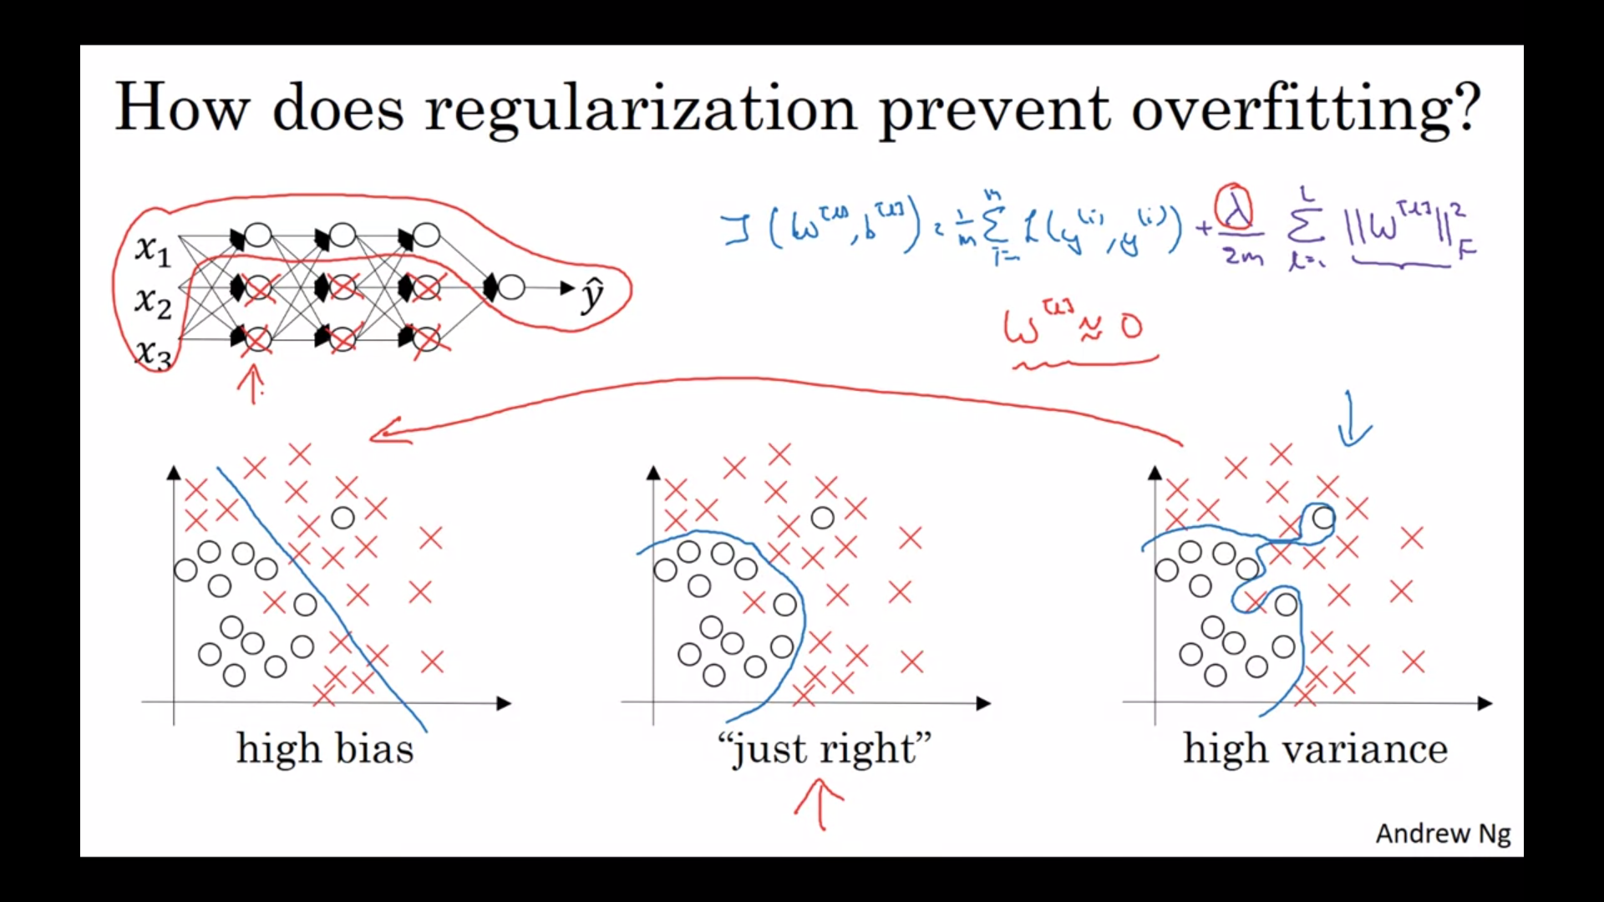

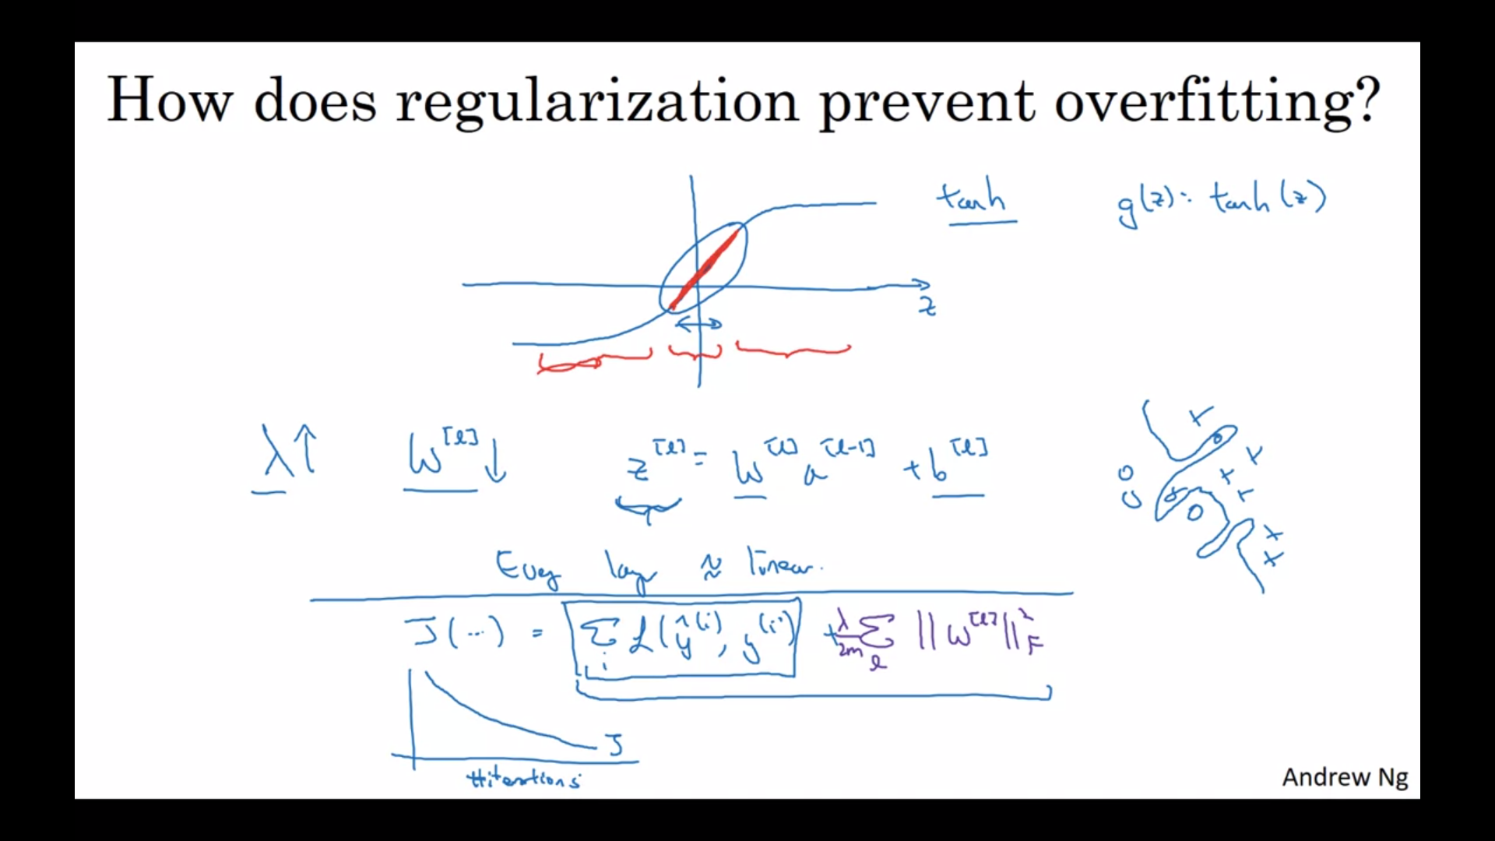

If you plot the old definition of J,

just this first term,

then you might not see a decrease monotonically.

So to debug gradient descent make sure that you're plotting

this new definition of J that includes this second term as well.

# Dropout Regularization

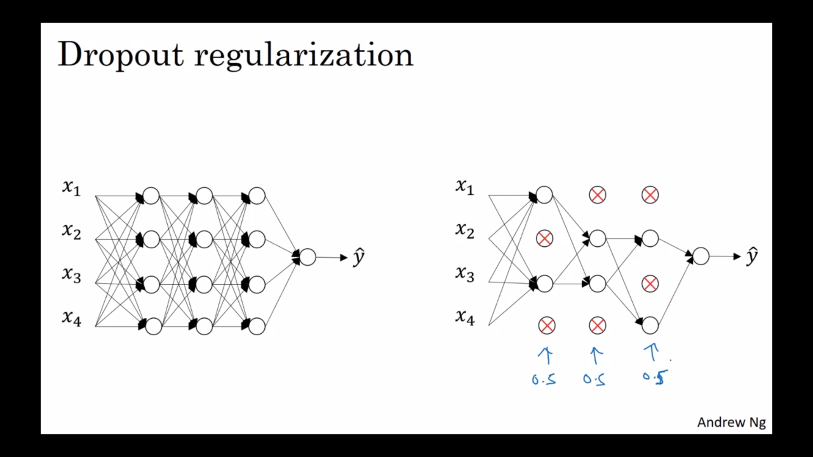

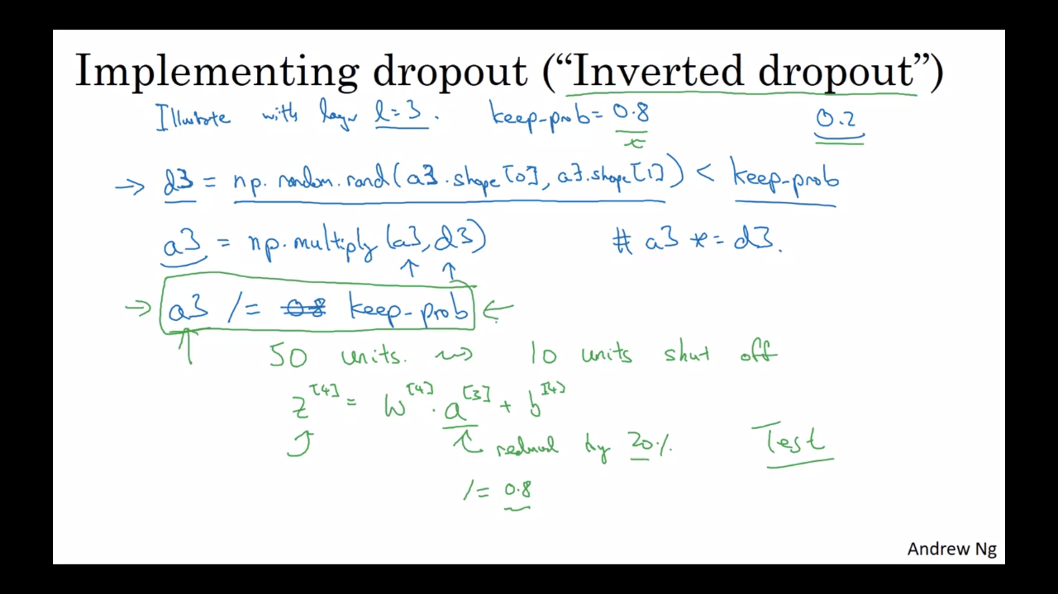

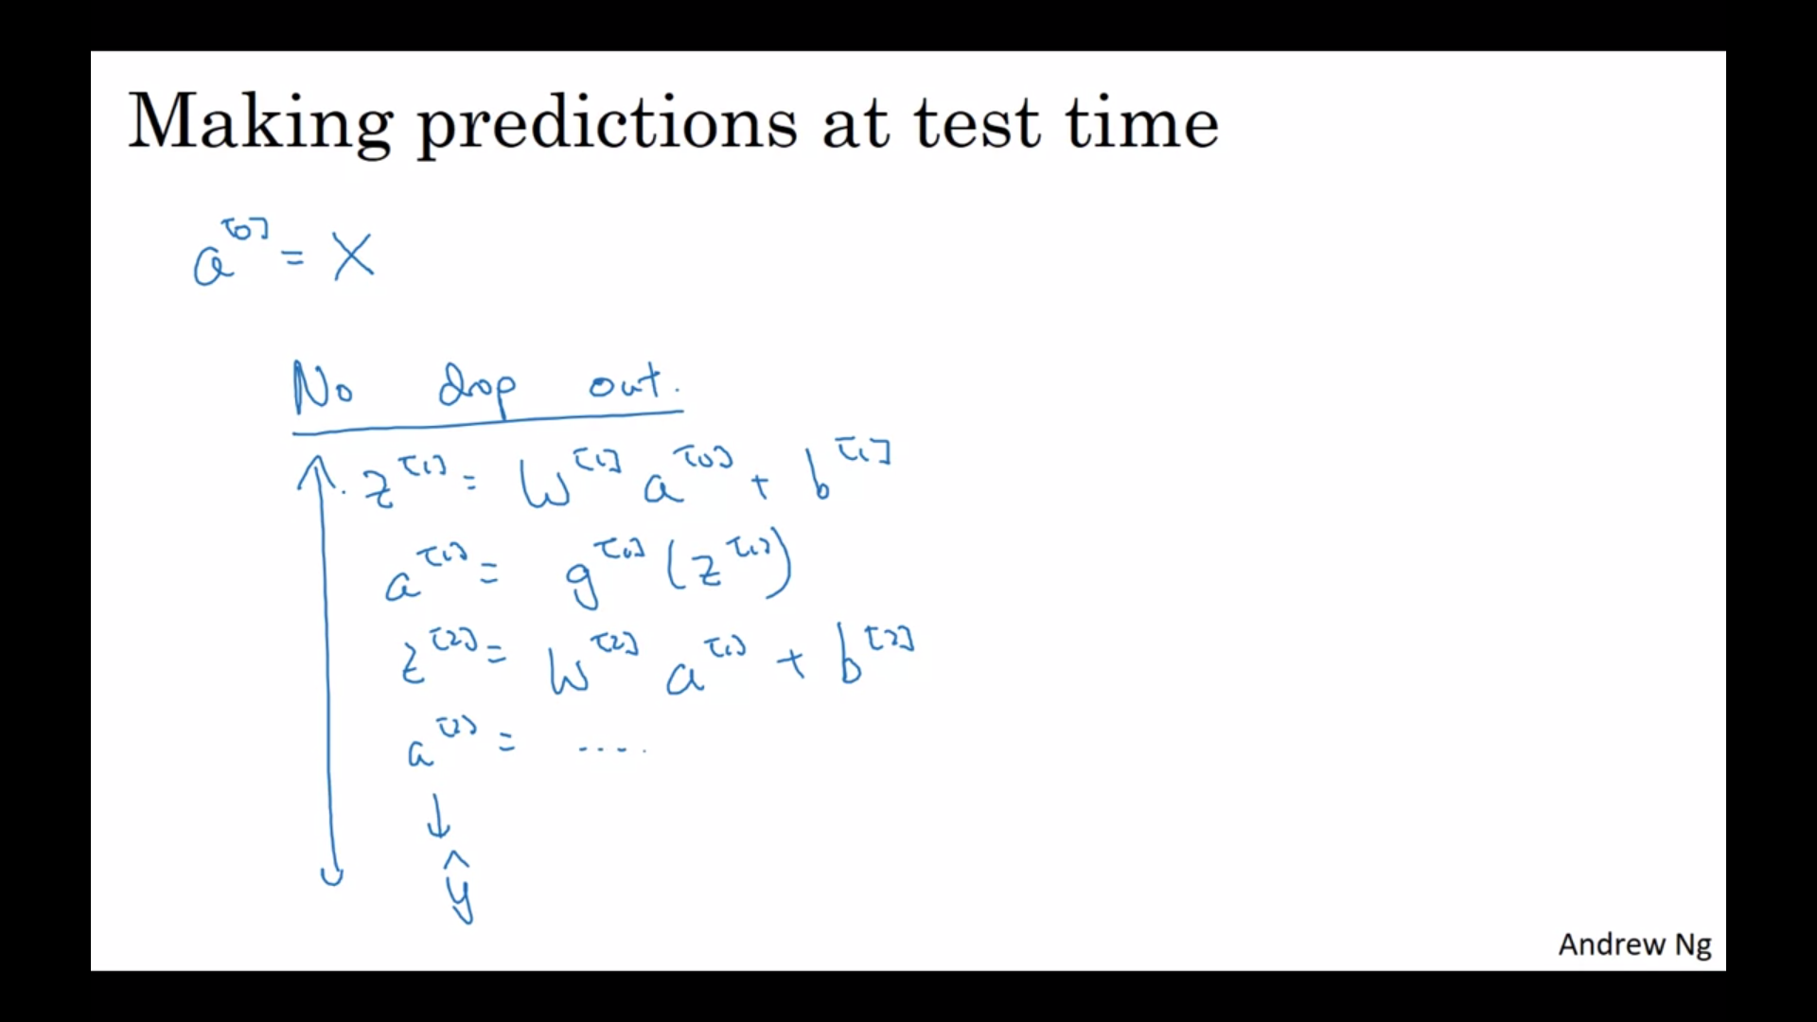

Backpropagation with drop out-

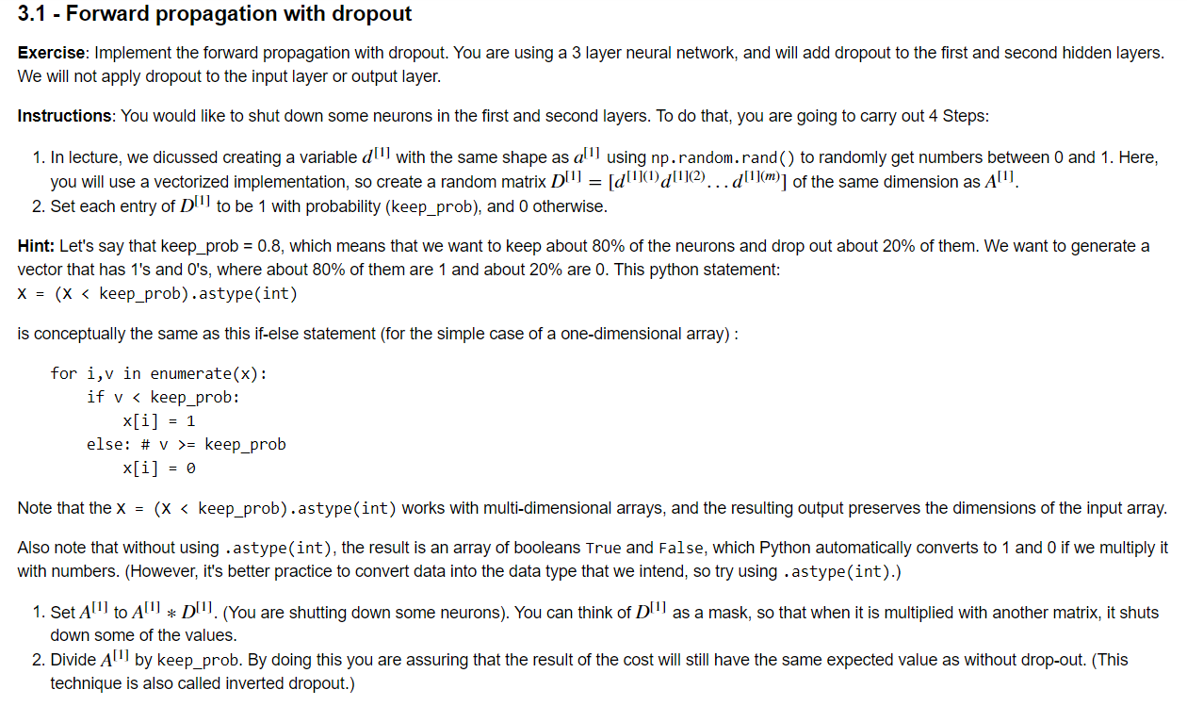

Back propagation with drop out-

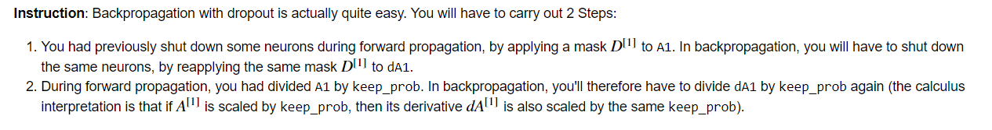

# Understanding Dropout

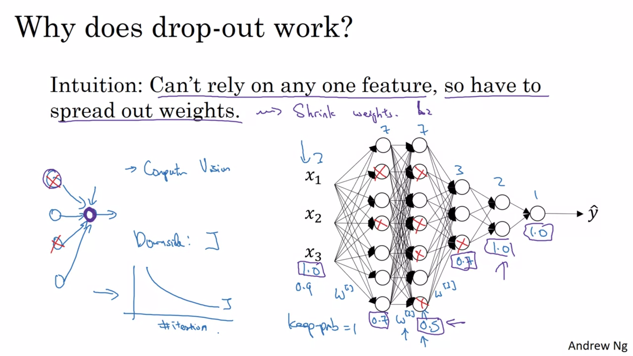

# Other regularization methods

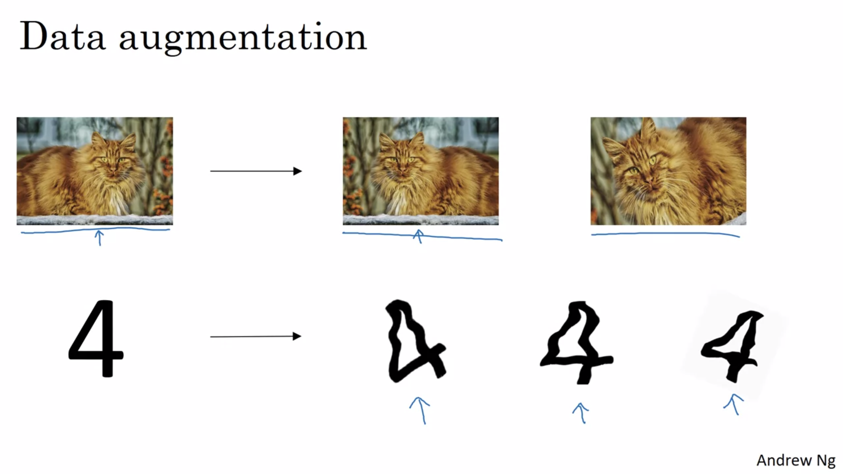

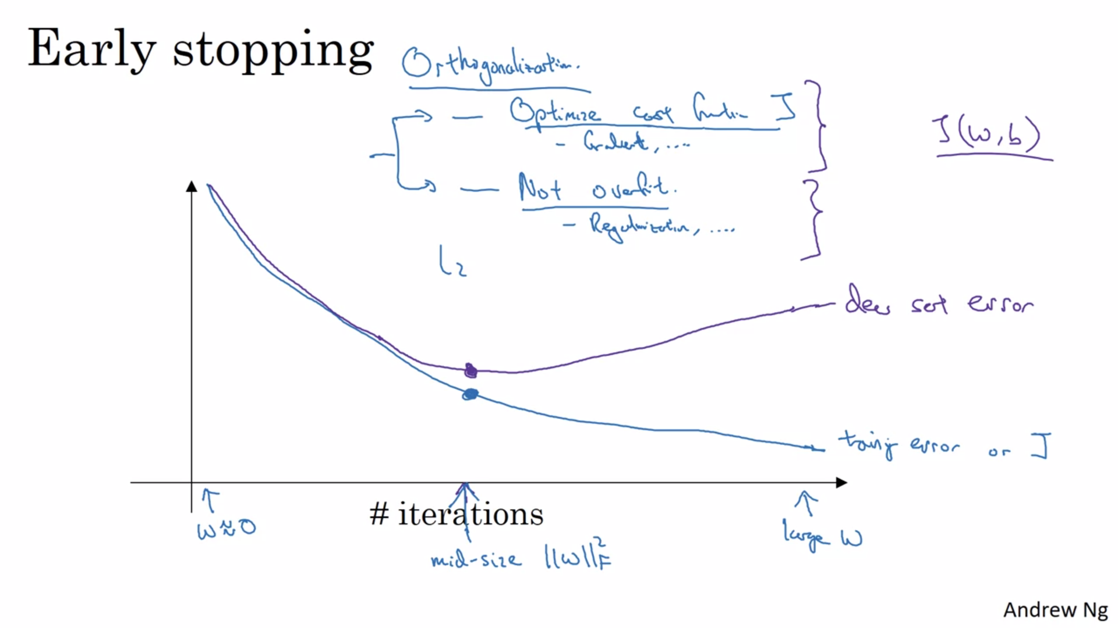

# Normalizing inputs

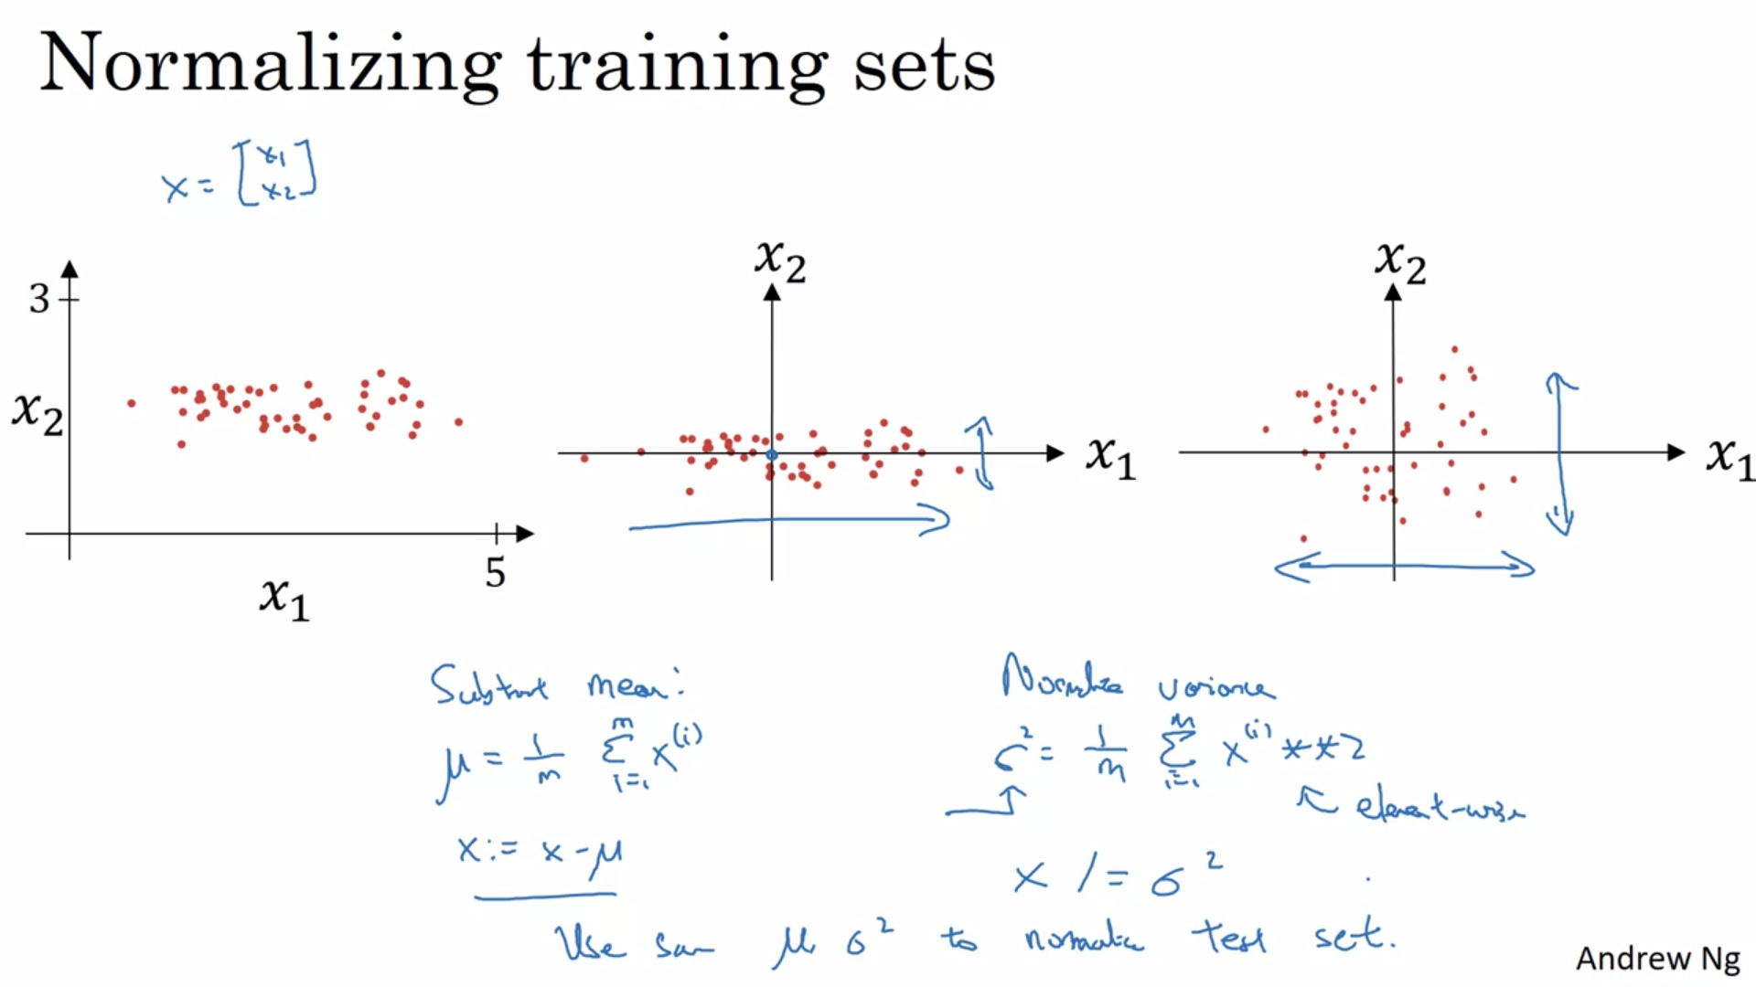

Some clarification for above image-

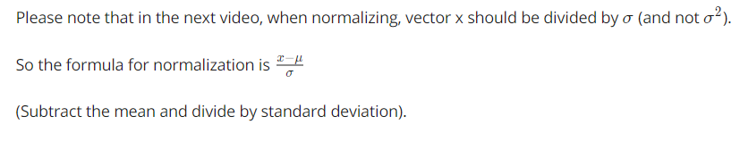

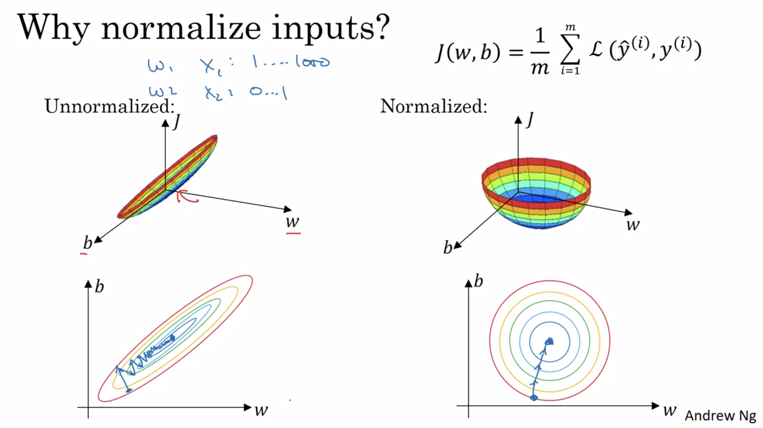

And if you're running gradient descent on the cost function like the one on

the left, then you might have to use a very small learning rate because if you're

here that gradient descent might need a lot of steps to oscillate back and

forth before it finally finds its way to the minimum.

Whereas if you have a more spherical contours, then wherever you start

gradient descent can pretty much go straight to the minimum.

You can take much larger steps with gradient descent rather than needing to

oscillate around like like the picture on the left.

# Vanishing / Exploding gradients

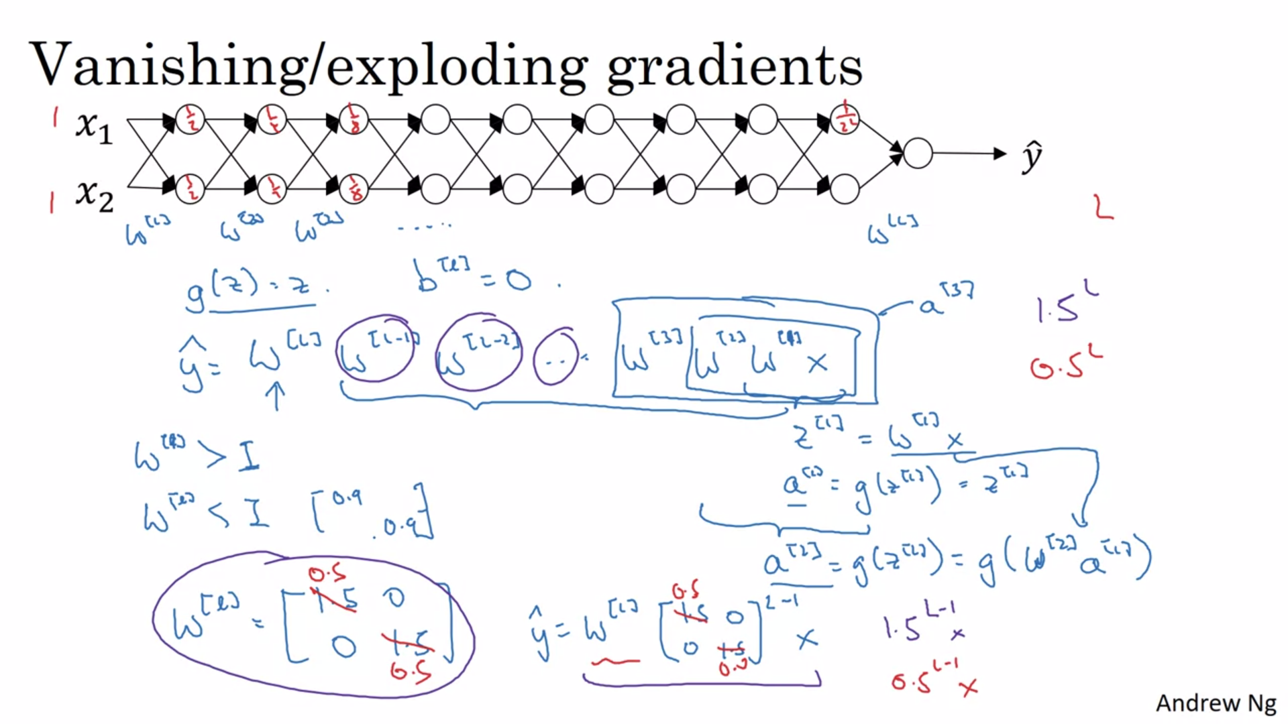

# Weight Initialization for Deep Networks

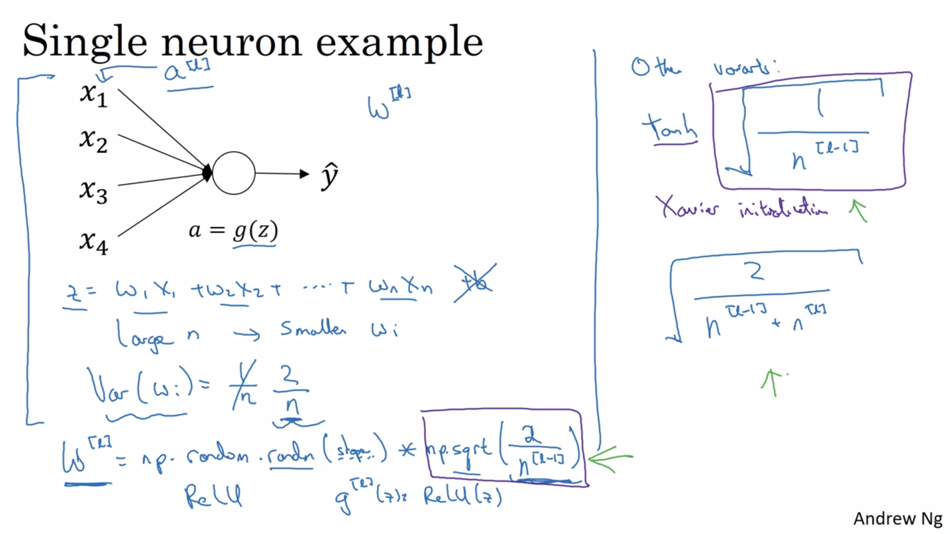

# Numerical approximation of gradients

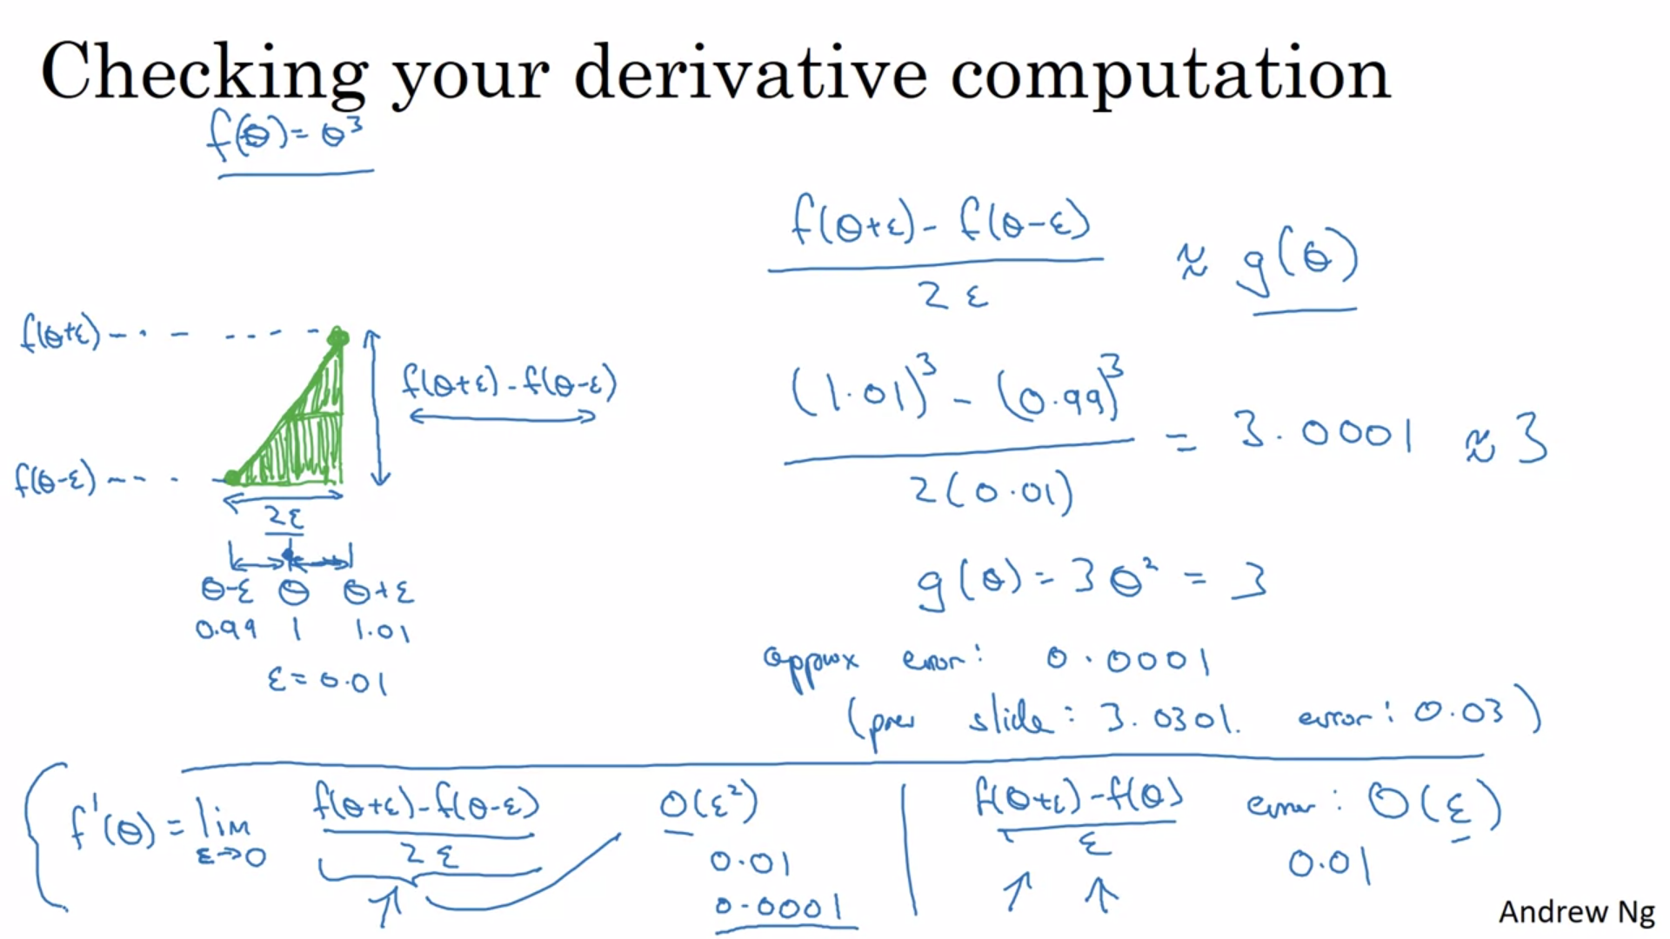

# Gradient checking

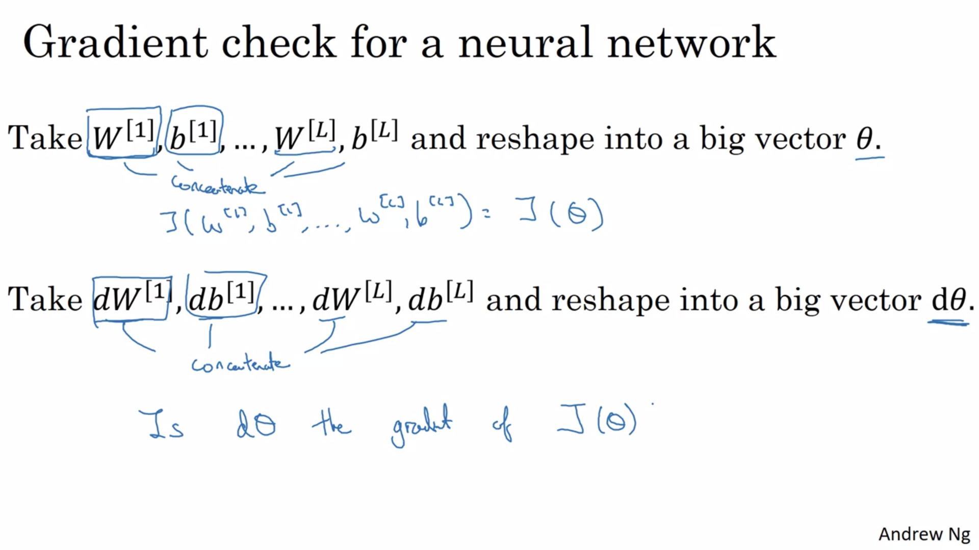

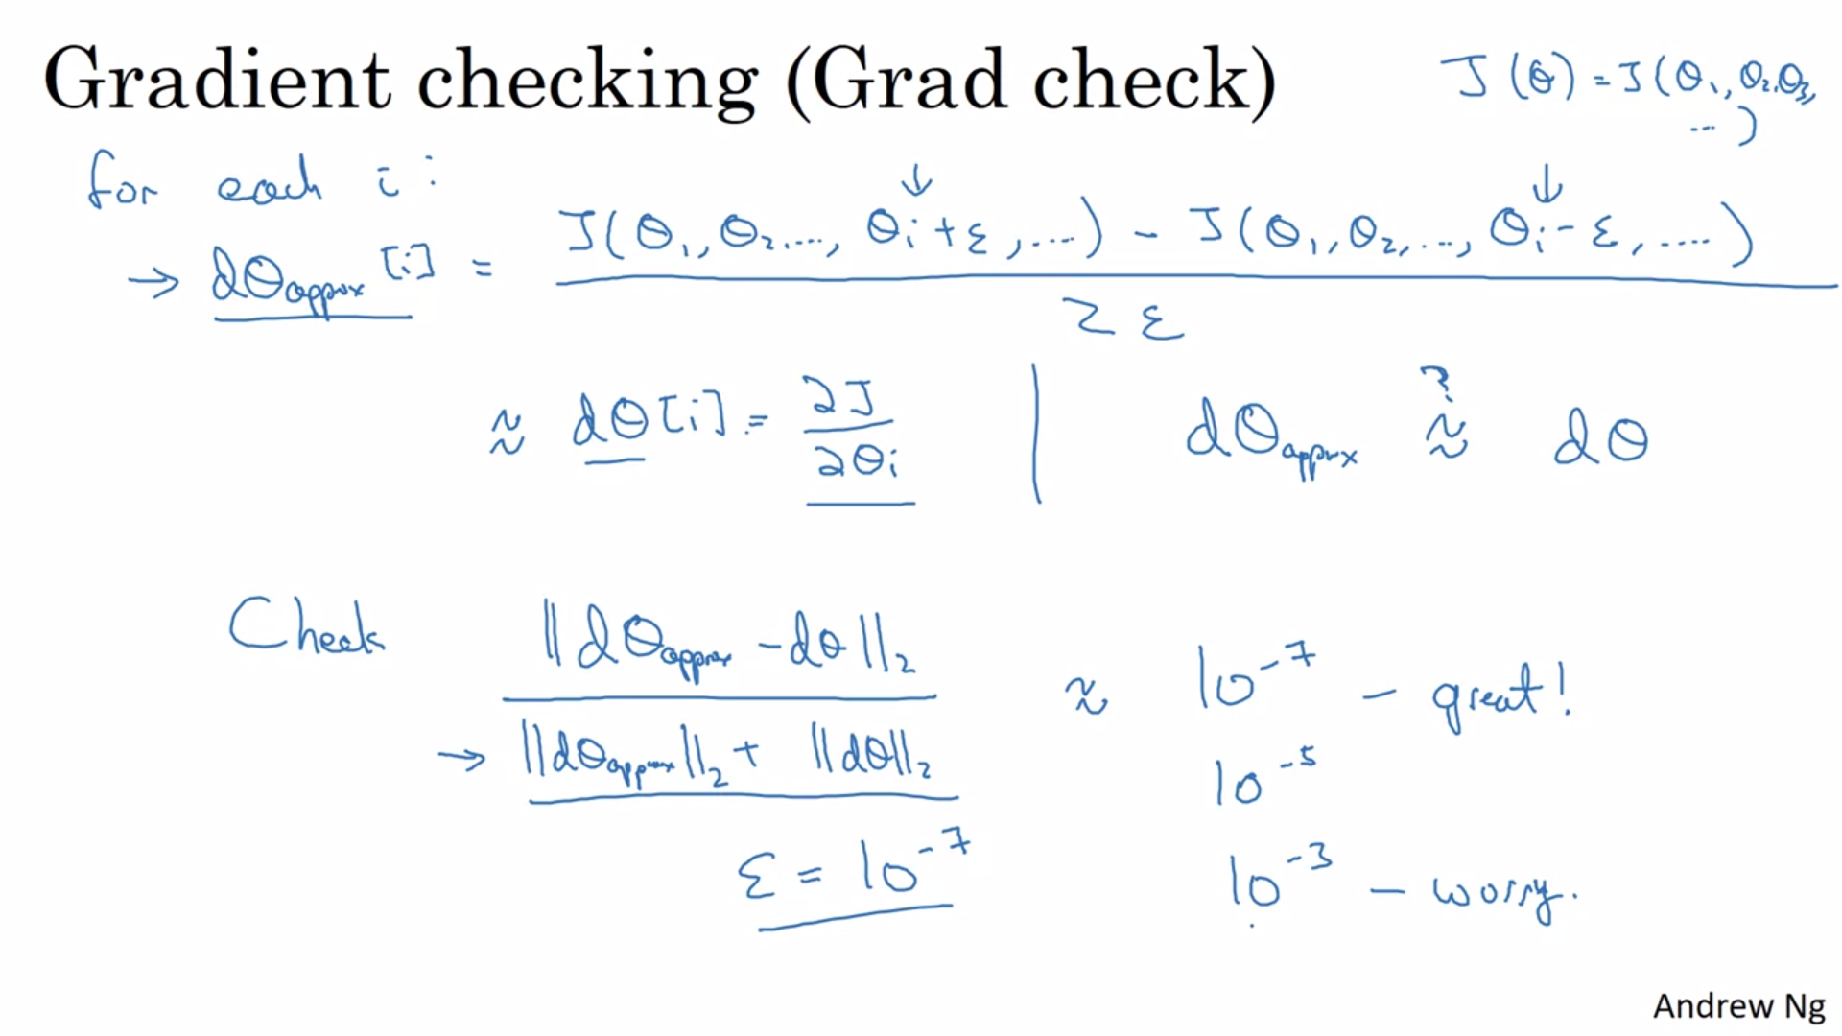

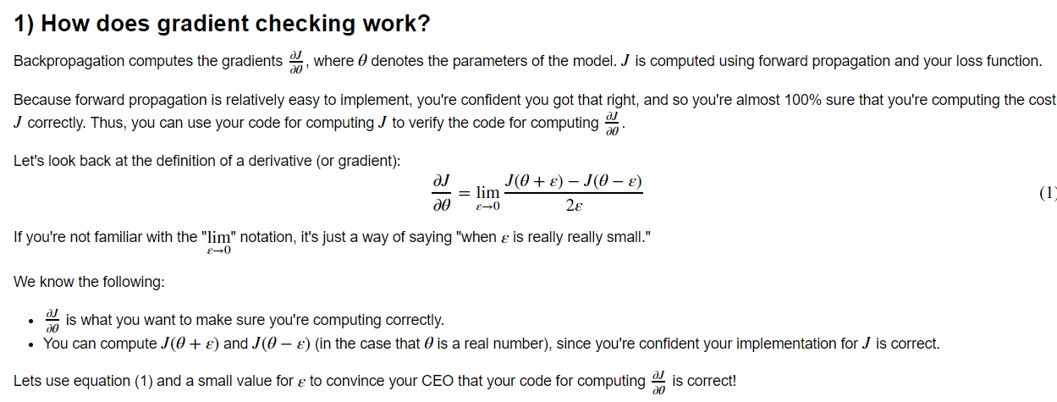

# Gradient Checking Implementation Notes

